MINI PROJECT
Data Pre-processing using Microsoft Excel
Dataset – Global Freelancers Data
Data pre-processing steps:
- Data Overview
The raw dataset of Global Freelancers was downloaded from Kaggle. Looked through the dataset structure to spot inconsistency and plan the cleaning steps.

- Removing duplicates
Removed duplicate rows to make sure every record in the dataset is unique. As result, no duplicates were found. All 1000 rows were unique.

- Handling Missing Data
Handled missing data by detecting null values and imputing missing records appropriately.
There were missing data in Age, experience and hourly rates which were found and filled manually. There were missing data in Rating, Activity and Client Satisfaction which were filled using formulae. Used the Go to Special (Blanks) tool to apply dynamic formulas specifically to empty cells, ensuring non-blank data remained intact.

- Created Excel table
Transformed the processed dataset into a structured Excel table format using Ctrl + T and chose an apt theme to ensure enhanced readability, standardized data organization dynamic Formula & Calculation Support.

- Created New Columns
Five new columns were created:
- Age Group – Created next to Age, calculated using IFS condition, it shows in which age group every freelancer belongs to.
- Experience Level – Created next to experience(years), calculated using IFS condition based on years of experience, which shows whether a freelancer is a junior, mid-level, senior, super senior or an expert.
- Est. Annual Revenue – Created next to hourly rate, calculated by multiplying hourly rate with 1000 (1000-which is hourly billable rate in a year)
- Pricing Tier - Created next to Est. Annual Revenue, calculated using IFS condition based on hourly rate, which shows whether a freelancer fee is in budget, standard or premium.
- Performance - Created next to client satisfaction, calculated using IFS condition based on rating, which shows whether a freelancer is a top performer, average or needs improvement.

- Conditional Formatting
Applied column-specific conditional formatting rules across multiple attributes to visually differentiate data ranges, distinct categories, and outlier values.
Data Bars (Solid & Gradient), Highlight cell rules (equal to) and Icon sets (shapes) are used in various columns.
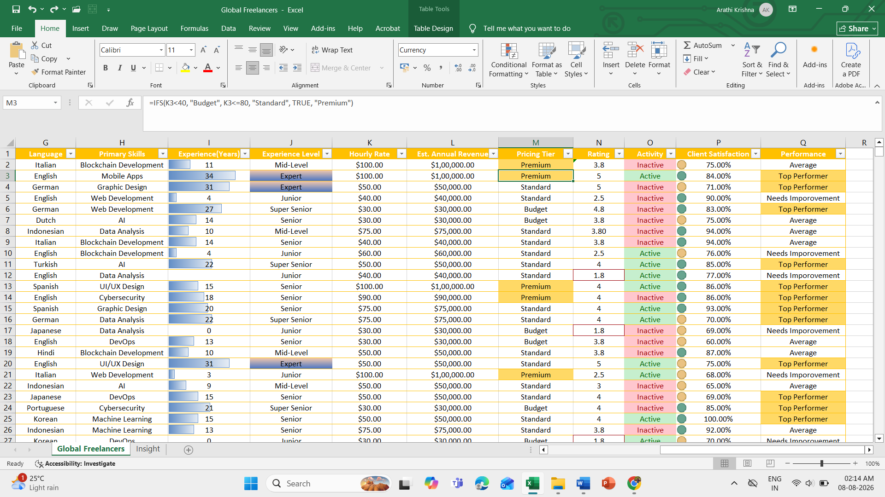

- Pivot Charts
Generated a Pivot Table to analyze Hourly Rate and Estimated Annual Revenue across Experience Levels, and visually communicated the findings using a combination (column-line) chart.
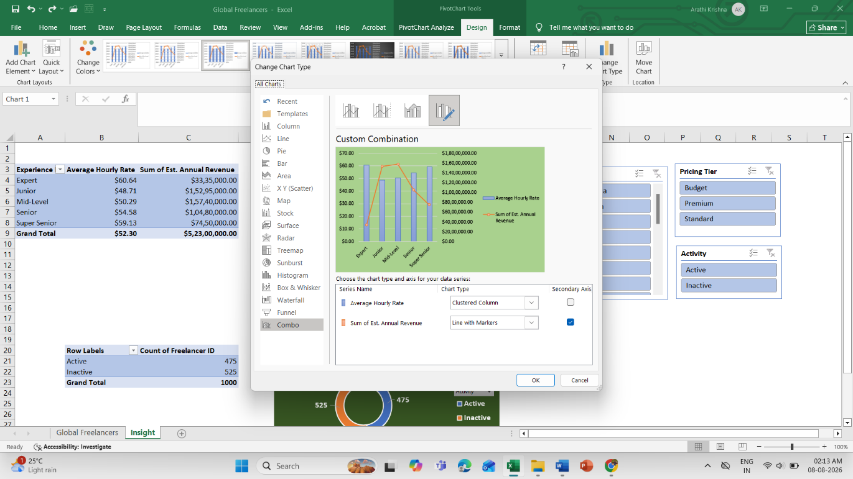
Constructed a Pivot Table to analyze the distribution of active versus inactive freelancers, accompanied by a donut chart to clearly illustrate the proportional split.
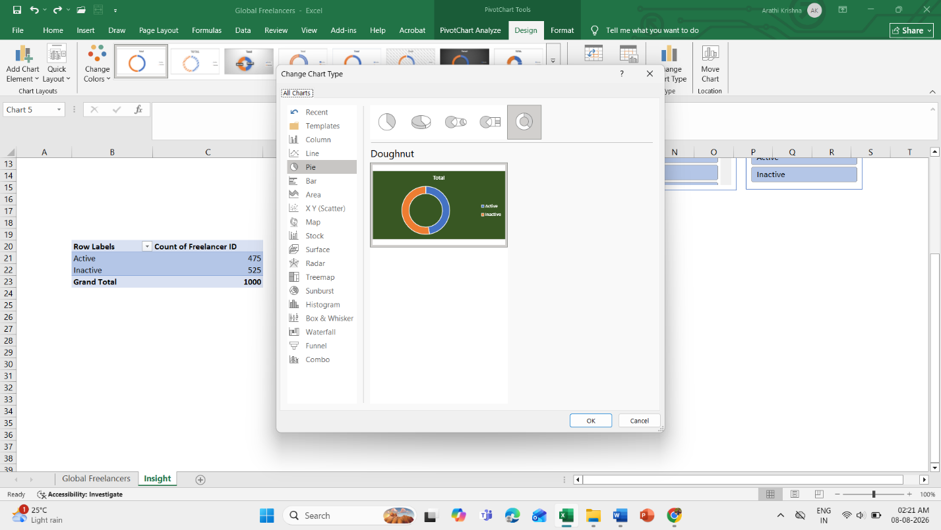

- Slicers
Implemented three distinct slicers (Country, Pricing Tier, and Activity) to enable multi-dimensional filtering across the dashboard.

